**NUTRITION ASSISTANT APPLICATION**

Project Report

*Submitted by*

**TEAM ID: PNT2022TMID34668**

**Sahaya Nishima D**

**Sweetlin Sajoni Joy J**

**Reni Shajila S**

**Sobhra R S**

TABLE OF CONTENT

|  |  |
| --- | --- |
| S. No | TITLE |
| 1 | **INTRODUCTION**  1.1 Project Overview  1.2 Purpose |
| 2 | **LITERATURE SURVEY**  2.1 Existing problem  2.2 References  2.3 Problem Statement Deﬁnition |
| 3 | **IDEATION & PROPOSED SOLUTION**  3.1 Empathy Map Canvas  3.2 Ideation & Brainstorming  3.3 Proposed Solution  3.4 Problem Solution ﬁt |
| 4 | **REQUIREMENT ANALYSIS**  4.1 Functional requirement  4.2 Non-Functional requirements |
| 5 | **PROJECT DESIGN**  5.1 Data Flow Diagrams  5.2 Solution & Technical Architecture  5.3 User Stories |

|  |  |
| --- | --- |
| 6 | **PROJECT PLANNING & SCHEDULING**  6.1 Sprint Planning & Estimation  6.2 Sprint Delivery Schedule  6.3 Reports from JIRA |
| 7 | **CODING & SOLUTIONING**  7.1 Feature 1  7.2 Feature 2 |
| 8 | **TESTING**  8.1 Test Cases  8.2 User Acceptance Testing |
| 9 | **RESULTS**  9.1 Performance Metrics |
| 10 | **ADVANTAGES & DISADVANTAGES** |
| 11 | **CONCLUSION** |

|  |  |
| --- | --- |
| 12 | **FUTURE SCOPE** |
| 13 | **APPENDIX**  Source Code  GitHub & Project Demo Link |

**INTRODUCTION**

Due to the ignorance of healthy food habits, obesity rates are increasing at an alarming speed, and this is reflective of the risks to people’s health. People need to control their daily calorie intake by eating healthier foods, which is the most basic method to avoid obesity. However, although food packaging comes with nutrition (and calorie) labels, it’s still not very convenient for people to refer to App-based nutrient dashboard systems which can analyze real-time images of a meal and analyze it for nutritional content which can be very handy and improves the dietary habits, and therefore, helps in maintaining a healthy lifestyle.

***1.1 PROJECT OVERVIEW***

This project aims at building a web App that automatically estimates food attributes such as ingredients and nutritional value by classifying the input image of food. Our method employs **Clarifai's AI-Driven Food Detection Model** for accurate food identification and Food API's to give the nutritional value of the identified food.

***1.2 PURPOSE***

The users continue to demand to know the nutritional value that is in their food. The users learn about the effect of different foods on human health. Evidently, the ultimate aim of this application is to provide the ways in which one can lead a healthy life by maintaining his/her diet. The user can access the nutritional information by taking a photo of the food, uploading aphoto from the gallery, or by entering manually.

**LITERATURE SURVEY**

***2.1 EXISTING PROBLEM***

Due to the ignorance of healthy food habits, obesity rates are increasing at an alarming speed, and this is reflective of the risks to people’s health. People need to control their daily calorie intake by eating healthier foods, which is the most basic method to avoid obesity.

***2.2 REFERENCES***

[***https://ieeexplore.ieee.org/document/4782671***](https://ieeexplore.ieee.org/document/4782671)

[***https://ieeexplore.ieee.org/document/8118575***](https://ieeexplore.ieee.org/document/8118575)

***2.3 PROBLEM STATEMENT DEFINITION*** App-

based nutrient dashboard systems which can

analyze real-timeimages of a meal and analyze it for

nutritional content which can be very handy and

improves the dietary habits, and therefore, helps in

maintaining a healthy lifestyle

.

|  |  |  |  |  |
| --- | --- | --- | --- | --- |
| TITLE AND  AUTHOR(S) | YEAR | TECHNIQUE (S) | FINDINGS | PROS AND  CONS |
| Enhancing Cloud  and healthy Food  Nutrition  Information Systems Practice-  Paul, PK and Aithal, PS and Bhuimali, A | 2017 | Cloud  Computing,  Mobile  Computing | Among the common mass food information systems are not yet popularized as a domain and thus there are huge potentialities to  work on this. | P: Regarding  manpower  development there are a lot of things are pending and  possible to work  with. Hence cloud will do an attention on skill and  manpower  development for  sophisticated  development of food information systems. |
| Mobile cloud based system recognizing nutrition and  freshness of food  image-  Kumbhar, Diptee  and Patil, Sarita | 2017 | Cloud  Computing,  Image  Segmentation | Mobile cloud computing (MCC) has been introduced to be a  potential paradigm for mobile health services to overcome the interoperability issues over  distinctive information formats. In this, we propose a mobile cloud- based food calorie measurement  framework. | P: Multiple  Platform Support. Cost-Efficient |
| C: Connectivity and Performance Issues |

|  |  |  |  |  |
| --- | --- | --- | --- | --- |
| Predicting calorific value for mixed food using image  processing-  Kohila, R and  Meenakumari, R | 2017 | Cloud  Computing,  Image  Segmentation | The objective of this paper is to  predict and to fix diet control for various diseases by measuring the calorific value to help the patients and nutritionists. The image  captured through a mobile  phone/tablet camera will provide information concerning the calorie rate of the food. | P: Increased  security  Reduced cost |
| C: Limited control . Lacks Support |
| Use of artificial  intelligence in  precision nutrition and fitness-  de Moraes Lopes,  Maria Helena Baena and Ferreira, Danton Diego and Ferreira, Ana Claudia Barbosa Honorio and da  Silva, Giuliano  Roberto and  Caetano, Aletha  Silva and Braz | 2020 | Artificial  Intelligence,  Nutritional  surveillance | Among the available  computational tools, artificial  intelligence (AI) has gained more and more attention recently, since it is able to learn and model linear  and nonlinear relationships  between variables by constructing an input-output mapping such that hidden and extremely useful  information for decision-making is revealed and interprete. | P: A large amount of data is collected by these  technologies |
| C:AI is not yet  widely used in the areas of nutrition and fitness |

**IDEATION & PROPOSED SOLUTION**

***3.1 EMPATHY MAP CANVAS***

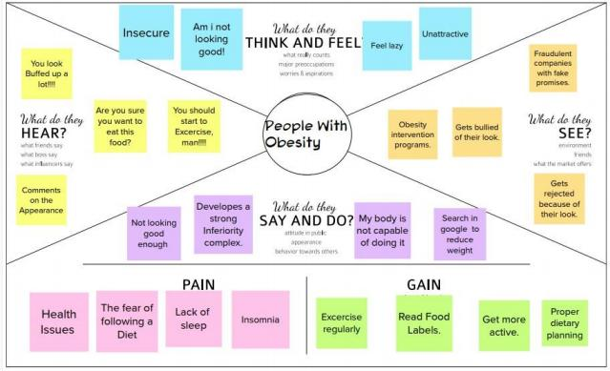

***3.2 IDEATION & BRAINSTORMING***

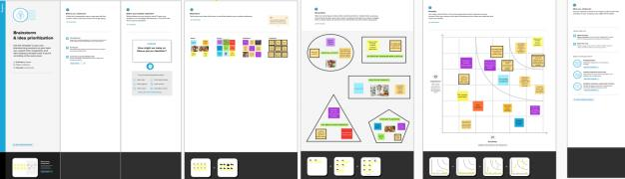

***3.3 PROPOSED SOLUTION***

|  |  |  |
| --- | --- | --- |
| **S.No.** | **Parameter** | **Description** |
| 1. | Problem Statement (Problem to besolved) | Rate of Obesity are increasing at an high speed,due to the ignorance of the proper Nutrition foods, and this leads to risks in people's health. People need to control their daily calorie intake by eating  healthier foods, which is the most basic  method to avoid obesity.However,some  food packaging has an added nutrition and  calorie values,but it's not  very comfortable to refer. |
| 2. | Idea / Solution description | People can easily track the Nutrition and  calories by scanning an real-time images of a food and examine it's nutritional content  which will improves the dietary habits.Smart nutrition and foods can prevent diseases.  This app will provide proper nutrition,helps in maintaining a healthy lifestyle and also  recommended diet  plans for users. |
| 3. | Novelty / Uniqueness | This solution has the uniqueness that we can realize realtime images of meal and can easily analyze its nutritional content. A web app that can automatically estimates food attributes such as ingredients and  nutrition value by  classifying the input image. |
| 4. | Social Impact / Customer  Satisfaction | The Obesity rate will get reduced and people  can able to lead a healthy life. It helps achieveand maintain a healthy weight. |
| 5. | Business Model (Revenue Model) | Social media is the best way to develop this application. This application will increase  the confidence among the people. It is great to use,  amazing convenience and also have subscription once user hit certain  services. |
| 6. | Scalability of the Solution | People can access from anywhere at  anytime to track the calories and nutrition value that will improve a healthy eating  pattern. This App will improves the dictary habits and helps in  maintaining a healthy weight and  healthylifestyle. |

***3.4 PROBLEM SOLUTION FIT***

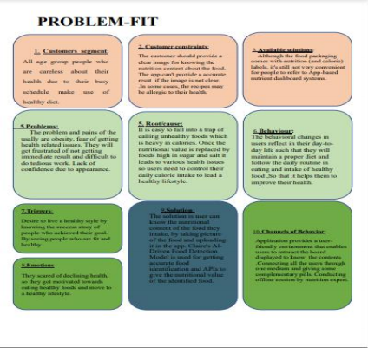

**REQUIREMENT ANALYSIS**

***4.1 FUNCTIONAL REQUIREMENT***

|  |  |
| --- | --- |
| **IDENTIFIER** | **REQUIREMENTS** |
| 1. Add health information | This application will allow to add health related information of the user. |
| 2. Delete health information | This application will allow to delete the unwanted details about their health. |
| 3. Categories of nutritional food | The categories of food. |
| 4. View of Dashboard | Application will allow user to view the dashboard containing nutrition details. |
| 5. Identifying the high calorie food | The high calorie ingredients will be shown  via this application. |
| 6. Identifying the low calorie food | The high calorie ingredients will be shown  via this application. |

***4.2 NON-FUNCTIONAL REQUIREMENTS***

1. Usability

2. Security

3. Reliability

4. Performance

5. Availability

6. Scalability

**PROJECT DESIGN**

***5.1 DATA FLOW DIAGRAMS***

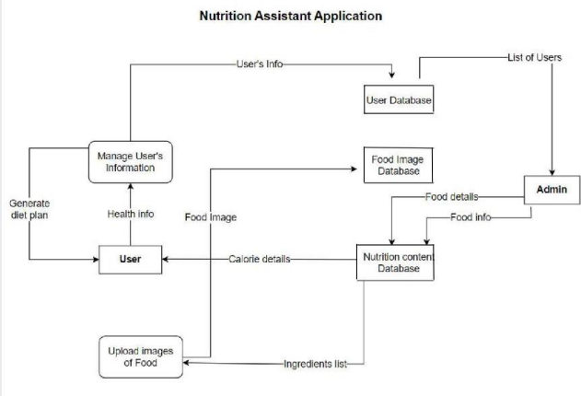

***5.2 SOLUTION & TECHNICAL ARCHITECTURE***

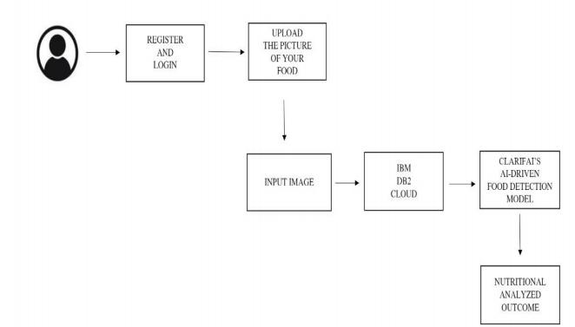

***5.3 USER STORIES***

1. As a user, I can register for the application by entering my email, password,and Conﬁrm my password

2. As a user, I will receive conﬁrmation email once I have registered forthe application

3. As a user, I can loginto the application by entering email & password

4. As a user, I can ﬁll the details.

5. As a user, I can register for the application by entering my email, password,and Conﬁrm my password

6. As a user, I will receive conﬁrmation email once I have registered forthe application

7. As a user, I can loginto the application by entering email & password

8. As a user, I can ﬁll the details.

9. As a user,Iwill search the food items.

10. As a user, I can scan the food an get the nutrition details and recipe for relatedscanned food.

**PROJECT PLANNING & SCHEDULING**

***6.1 SPRINT PLANNING & ESTIMATION***

|  |  |  |  |  |  |  |
| --- | --- | --- | --- | --- | --- | --- |
| SPRNT | FUNCTINAL  REQUIREMENT | USER  STORY  NUMBER | User Story / Task | STORY  POINTS | PRIORITY | TEAM  MEMBERS |
| Sprint- 1 | Registration | USN- 1 | As a user, I can register for the  application by entering my email,  password, and confirming my Anusha K password. | ***2*** | High | Sahaya Nishima  Sweetlin Sajoni joy  Reni Shajila  Sobhra |
| Sprint- 1 |  | USN-2 | As a user, I will receive confirmation email once have registered for the application | ***1*** | High | Sahaya Nishima  Sweetlin Sajoni joy  Reni Shajila  Sobhra |
| Sprint- 1 | Login | USN-3 | As a user, I can log into the application by entering email & password | ***1*** | High | Sahaya Nishima  Sweetlin Sajoni joy  Reni Shajila  Sobhra |
| Sprint-2 | User details | USN-4 | As a user , I can fill the Details. | ***2*** | High | Sahaya Nishima  Sweetlin Sajoni joy  Reni Shajila  Sobhra |
| Sprint-3 | Push  notification | USN-5 | As a user, Iwill search the food items. | ***2*** | Medium | Sahaya Nishima  Sweetlin Sajoni joy  Reni Shajila  Sobhra |
| Sprint-4 | Shown the  nutrition details and recipe for scanned food | USN-6 | As a user, I can scan the food an get the details and Recipe for nutrition  details and recipe for related scanned food. | ***1*** | High | Sahaya Nishima  Sweetlin Sajoni joy  Reni Shajila  Sobhra |

***6.2 SPRINT DELIVERY SCHEDULE***

|  |  |  |  |  |  |  |
| --- | --- | --- | --- | --- | --- | --- |
| Sprint | Total  Story  Points | Duration | Sprint Start Date | Sprint End Date  (Planned) | Story Points  Completed (as  on Planned End  Date) | Sprint Release Date  (Actual) |
| Sprint-1 | 20 | 6 Days | 24 Oct 2022 | 29 Oct 2022 | 20 | 12 Nov 2022 |
| Sprint-1 | 20 | 6 Days | 31 Oct 2022 | 05 Nov 2022 | 20 | *05 Nov 2022* |
| Sprint-1 | 20 | 6 Days | 07 Nov 2022 | 12 Nov 2022 | 20 | *12 Nov 2022* |
| Sprint-1 | 20 | 6 Days | 07 Nov 2022 | 12 Nov 2022 | 20 | *19 ov 2022* |

***6.3 JIRA REPORT***

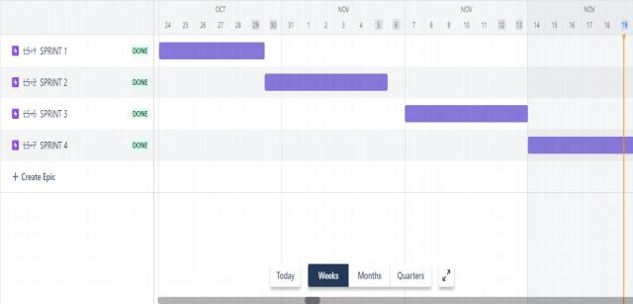

***BURNT DOWN CHART***

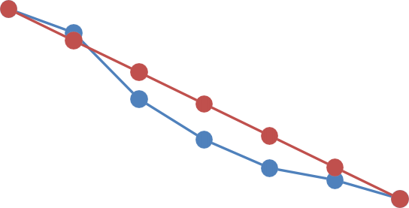

|  |
| --- |
| **BurntDown Chart**  **80**  **70**  **66.66666667**  **53.33333333**  **42**  **40**  **26.66666667**  **13 13.33333333 8**  **0**  DAY 0 DAY 1 DAY 2 DAY 3 DAY 4 DAY 5 DAY 6  remaining effort  ideal effort |

**25**

**CODING & SOLUTIONING**

***7.1 FEATURE 1***

✓ Enter the credentials to register and login to our Nutrino

✓ Already a user , use the login directly.

✓ Wrong login credentials will be notified.

✓ On correct username and password , user is directed to profile page .

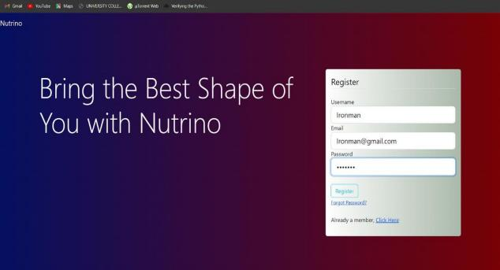

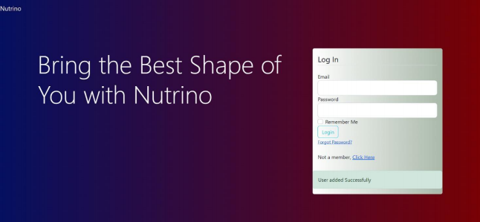

***7.2 FEATURE 2***

✓ ***User is taken to the profile page , and the user’s details***

***are collected.***

✓***The BMI for the user’s information is provided.***

✓ ***The dashboard with the user’s daily intake of calorie is***

***displayed.***

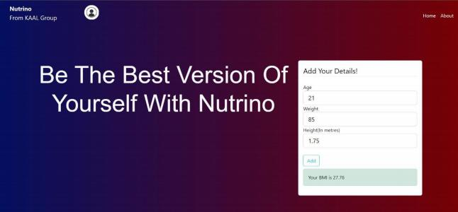

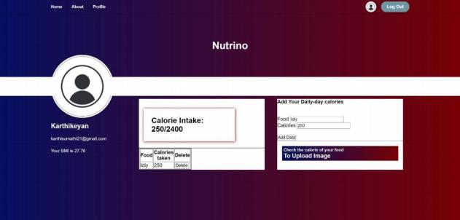

***TESTING***

***8.1 TEST CASES***

i. Our code was tested on different food to check whether it gives the correct ouput .

ii. The code is tested in every aspect to fulfill the customer’s requirements

***8.2 USER ACCEPTANCE TESTING***

Our project is tested by an user to verify the working of the application

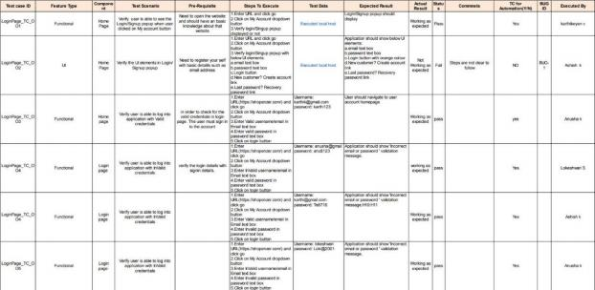

**RESULTS**

***9.1 PERFORMANCE METRICS***

The proposed procedure was implemented and tested on a set of different food images. The database consists of various images of food items . Once a food is recognized the equivalent nutritional values

displayed on the screen.

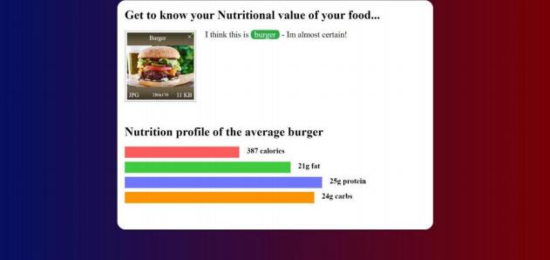

**ADVANTAGES**

1. User is now able to track his daily calorie intake

2. He/she can now take effective measures to maintain a healthy bodyweight

3. It delivers the information on the nutritional value for food and how it should be maintained for your daily basis .

**CONCLUSION**

In our conclusion , many people now-a-days are not aware of their health

condition and taking this conditions in hands and to save their time and

money , and to lead the healthy life style , the change in food routine

should be maintained . The goal of user either to increase or decrease

bodyweight through regular calorie-intake tracking with simple yet

efficient application is achieved. The users following theirrespective

calories is highly enough to get them FIT.

**FUTURE SCOPE**

In future we’ll be adding extra features that will engage our users a lot

more . The interaction with the users will be a lot more easier . And extra

dietary plans will be added for the user’s .

**APPENDIX**

***13.1 SOURCE CODE***

